**Full Stack Development lll – Lab 3**

* Network and Socket.io & Timers

**Developer Note:**

* Try to solve the problems without using search engines or stack overflow for the solutions.
* Create separate files for each exercise

**Exercise 1: Timers**

* Use the **setInterval create a script that will log to console 10 times**
  + There must be a 1 second delay before the next log message
  + The interval must stop and exit after 10 log messages and log “**times up!**’

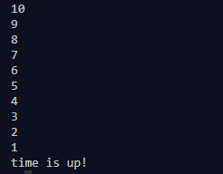

**Exercise 2: Intro to Socket.io**

* Use the **starter socket.io** application code and the socket.io documentation to do the following:
  + <https://socket.io/get-started/chat/> (Socket.io Documentation)
  + <https://tinyurl.com/y7eel6s7> (Socket.io Starter Application)
* **Server**
  + set up a listener event for any new socket.io connections and log it to the console
  + set up a listener for client sockets disconnecting and log it to console
  + setup a listener for messages sent from a client socket and log it to console
* **Client**
  + wire up the 'Connect' button to send a socket connect event
  + wire up the 'Disconnect' button to send a socket disconnect event
  + wire up the 'Send Message' button to send a 'Hello sever' message to server

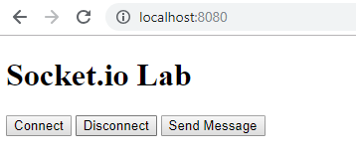

**Output**

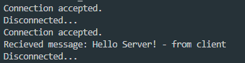

**Challenge : Build a Chat Application**

1. Open a command prompt create a directory for **chat-app**
2. Open Visual Studio Code and open the folder **chat-app**
3. Use the following starter code to start this application

<https://tinyurl.com/r3yel3p>

4. At the command line **run npm install** to install the chat application dependencies.

5. Complete the following tutorial to create a Chat Application using Express and Socket.io

<https://medium.com/@noufel.gouirhate/build-a-simple-chat-app-with-node-js-and-socket-io-ea716c093088>